8 RED FLAGS in Weight Loss Research: How to Spot Them and What They Mean
- Published on July 30, 2018

Jon Robison

Following Unfollow
Founding Partner at Salveopartners 106 articles
- Like 69
- Comment 30
- 13
Write an article
Thanks to many brilliant colleagues who helped this evolve and especially to Rebecca Johnson for major editing and rearranging to make it so much more practicable.
“Most obese persons will not stay in treatment for obesity. Of those who stay in treatment, most will not lose weight and of those who do lose weight, most will regain it.”

Introduction
For the most part, these ominous words uttered in 1958 by famed obesity researcher Albert Stunkard still ring true today. Regardless of the population, the length and intensity of the program, the type of dietary and/or exercise intervention, the credentials of the people running the program and every other variable imaginable, the results of hundreds of studies have been remarkably consistent over the past 60 years.
- Some people lose weight during the program.
- Most people regain their lost weight.
- 1/3 to 2/3 of participants end up weighing more than when they started the program.
- The resulting weight cycling may be hazardous to participant’s health.
Despite this evidence, workplace weight loss programs, contests and competitions remain popular and promoters regularly make claims of “successful weight loss,” even though these interventions fail to produce significant, sustained weight loss for all but a small minority of participants. In fact, findings from a large and well conducted study in England suggest that the often-touted, dismal 5% success rate in this regard may be significantly exaggerated.
The consistency of these findings aligns closely with Dr. Stunkard’s comments of 60 years ago. In the words of the authors of the English study, for patients with a BMI of 30 or greater;
“Maintaining weight loss was rare and the probability of achieving normal weight was extremely low.”
Given the lack of efficacy of weight loss initiatives, the ethics of continuing to offer such programs has been questioned. As a review in the Journal of Obesity put it:
“It is unethical to continue to prescribe weight loss to patients and communities as a pathway to health, knowing the associated outcomes - weight regain and weight cycling - are connected to further stigmatization, poor health and well-being. The data suggest that a different approach [emphasis added] is needed to foster physical health and well-being within our patients and communities.”

A White Paper and An Intensive Lifestyle Intervention
So now we come to the latest in the seemingly endless litany of studies claiming to be different. Published by Optum, the white paper - 12 Month Medical Cost Savings Observed from Real Appeal Intensive Lifestyle Interventions - claims that their digital weight loss program resulted in significant cost savings for participants compared to nonparticipants.
Interestingly, there is no mention in the paper about how much weight was lost by how many participants in their program, which would seem to be of prime importance in evaluating the success of a “weight loss” program.
The authors do state that their program is “based on science,” being patterned after similar programs they refer to as Intensive Lifestyle Interventions (ILI), and they claim that previous research has “demonstrated that ILIs are highly effective at helping achieve clinically meaningful weight loss.” To evaluate the veracity of these claims I have chosen one of the ILIs they cited - the Look Ahead Trial.
This was a massive experimental study whose main goal was to determine if weight loss and lifestyle modification could reduce deaths from cardiovascular disease. The study involved 5145 diabetic participants in 16 centers across the United States with an average follow up time of 9.6 years.
Taking a closer look at the details of the white paper and the trial, we can identify issues that turn up in one or both and to some extent in all weight loss literature. Examining the following 8 red flags can help us be able to accurately evaluate the realities of the research.

The 8 Red Flags
Red Flag #1: Comparing participants to non-participants. This is one of the most common, flawed methodologies used in weight and wellness-related research. The claim is that if you divide a group of people into those who want to do something (lose weight, for example) and compare them to a group of those who do not, the difference in results between the two groups is due to the program rather than the relative difference in motivation.
This type of research has been shown to result in a dramatic overstatement of the benefits of an intervention. This is because participants always do better than non-participants, particularly in an undertaking such as personal health improvement in which motivation is key. In fact, participants often do better than non-participants, even before the intervention begins. The National Bureau of Economic Research has concluded that most of any improvement attributed to interventions using this study design should in fact be attributed to self-selection bias.
Red Flag #2: Using different denominators when demonstrating outcomes. This is the practice, also all too common in weight loss interventions, of including fewer people in the post-program or follow up data than started the intervention – what we refer to as The Last Man Standing Fallacy. It means that people who dropped out of the program (and thus were less likely to have positive results) are not included in the final analysis, which leads to a greater percentage of reported positive results.
For example, the following graphs represent weight loss in the first four years of the Look Ahead Trial. This was sent to me by a colleague who claimed it showed that 20% of the participants had achieved > 10% weight reduction.
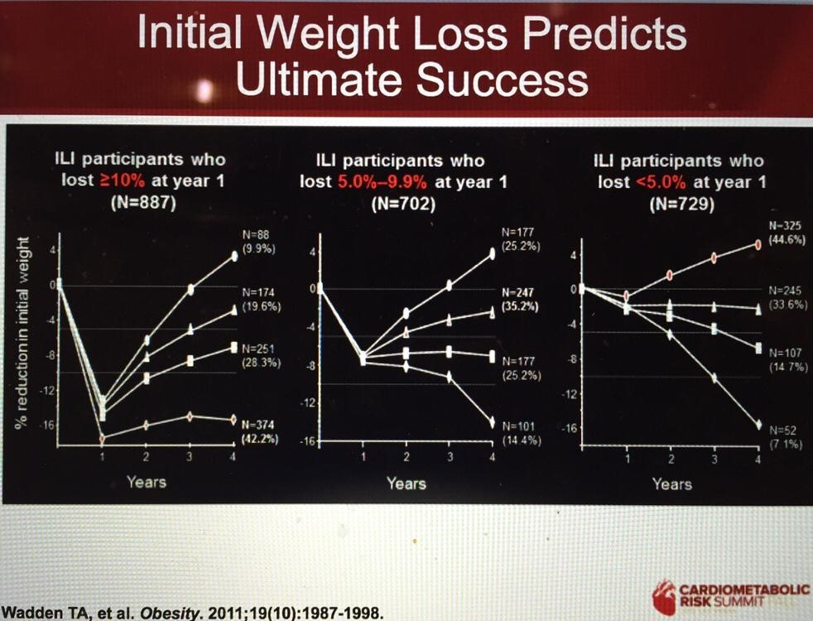
We see that the total number of participants being evaluated here is 2,318 (887+702+729). At the end of the 4 years, 527 (374+101+52) of those had managed to keep off 10% or more of their weight, from which the claim of 20% “success” was derived. However, remember that the study began with 5145 participants. So, the actual percentage that had achieved a 10% or greater weight loss after four years was much closer to 10% (527/5145) than to 20% (5145/2318). Just that small and inappropriate alteration in the denominator doubled the “success” of the intervention.
Red Flag #3: Calling it “maintenance” when the program is still ongoing
It is also common for weight loss programs to claim “maintenance” when, in fact, the intervention is still ongoing. The graph above shows weight loss results at the end of 4 years of the 8-year trial. This is clearly not about “maintenance” as these individuals are still involved in the intervention. This is simply a data point half way though, which makes the term “ultimate success” in the title of the graph misleading at best.
Further, as the graph above indicates (note the upward slope of the lines), of the participants who did lose 10% of their weight at year 1, the majority (513/887) or 58% were already gaining that weight back rather rapidly even though they were still participating in the intensive intervention. If you combine the numbers from the three graphs, what is quite evident is what you see in all weight loss interventions - rapid regain by most participants towards baseline, with 590/2318 or 25% of subjects already having regained at 4 years more than they lost in the first year, even though they were still participating.
Red Flag #4: Claiming your program is “highly effective at helping achieve clinically meaningful weight loss” when it really isn’t.
As the graph below of the final 8-year weight loss in the Look Ahead Trial depicts, participants on average lost about 8.5% of their weight during the first year. At the end of the 8th year that loss was down to 4.7% in the study group. The researchers, who had stated originally that the weight loss goal for “clinical significance” was 7-10%, nevertheless claimed that their study did prove that "it is possible to lose weight and keep it off." This is disingenuous, especially given the fact that weight loss did not reach the even lower bar of 5% that the Optum paper claimed was indicative of clinical significance.
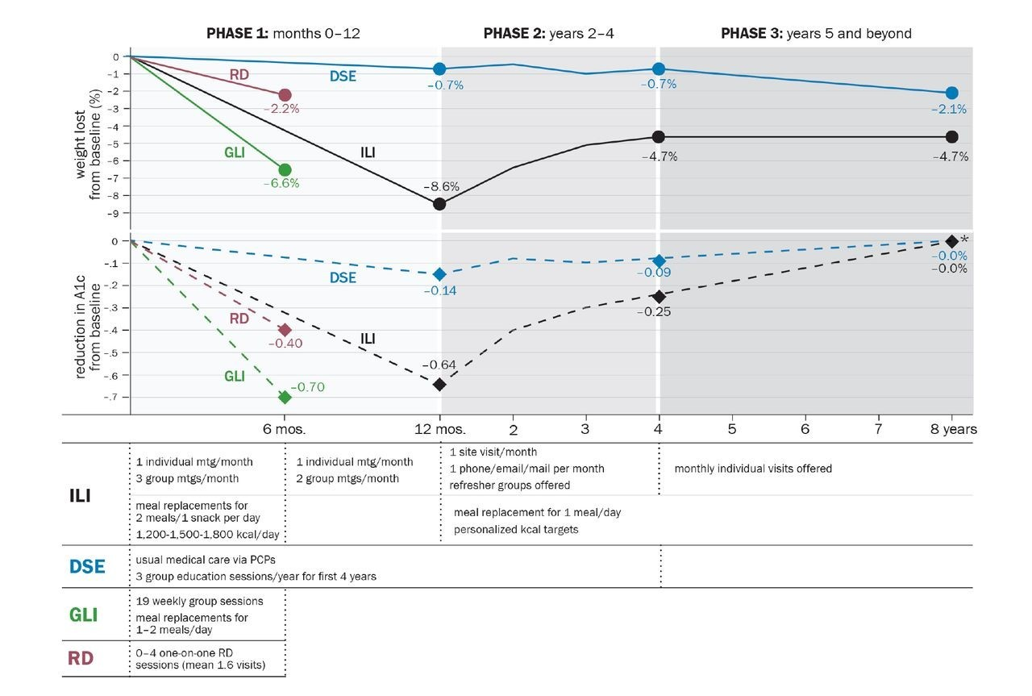
Perhaps even more importantly, as the top part of this graph demonstrates, at 8 years there was only a 2.6% difference in weight loss between the participants in the intensive intervention and those in the control group. The control group (blue line) lost an average of 2.1% of their weight at 8 years. To put all this into perspective, a 4.7% weight loss for most of the folks in this study corresponds to a change from a BMI of about 36 to one of about 34, which means that participants were still considered “obese” and in need of further weight loss, according to government guidelines.
And after 8 years the weight loss difference between experimental and control group participants amounted to about 1 BMI unit (5-7 pounds); a minimal difference for a multiple year, expensive, intensive intervention, and significantly at odds with the claim that these programs “are highly effective at helping achieve clinically meaningful weight loss.”
Red Flag #5: Not distinguishing between the health impact of weight loss and lifestyle change
The Look Ahead Trial was stopped early due to “futility of results,” meaning the trial failed to reduce deaths from cardiovascular disease in the experimental group vs. the control group. While there were some differences in other health outcomes, it is informative that as the bottom part of the previous graph depicts, initial improvements in A1C levels (blood test to diagnose type 2 diabetes and assess how well it is being managed) had fallen back to baseline by the time the trial was terminated. Whatever other changes in health may have occurred, the data are not able to tell us the reason for those improvements.
This is an important issue for weight loss interventions, especially ones such as this where there are multiple lifestyle targets such as exercise and nutrition, and where the weight losses are relatively minimal. The literature is clear that significant health improvements can occur with lifestyle interventions alone irrespective of changes in weight, and sometimes - here and here - even with increases in weight. It is simply not possible in the studies discussed in this paper, and in most weight loss research, to attribute the health improvements to changes in weight as opposed to changes in lifestyle.
Red Flag #6: Claiming Savings when there isn’t enough evidence to prove it
The claims of cost savings in the original white paper are unclear at best. For example, there is no definitive statement about who pays for medical costs and who pays for the coaching. It is hard to imagine, for example, that someone is not paying at least $60 for a session of coaching, which means that the claimed $254 savings for people attending 4 sessions (60X4 = $240) would be a wash, while the claimed $674 savings for participants attending 26 sessions would put them in the hole for $900 ($60x26 = $1560).
The paper also makes vague reference to the savings that “may” happen, presumably because they invoke the stereotype that fat people are sick and lazy and don’t show up to work. That number is not measured or referenced. In fact, recent research suggests that “obese” individuals do not incur higher costs at the workplace.
Finally, contrary to the claims in the white paper that ILIs are “relatively inexpensive,” the Look Ahead Trial incorporated many years of intensive, expensive interventions from physicians, registered dietitians, psychologists and exercise specialists, including scores of individual and group sessions, and weight loss drugs for some participants; hardly inexpensive, and probably the reason it is referred to as an “intensive” intervention.
Red Flag #7: Not considering the age of participants
Though this issue is likely less common in the weight loss research than some of the others, it certainly may play a role in the case of Look Ahead. The average age of the participants entering this trial was 58. This means that when the trial was stopped most participants were 65 or older. A significant portion of the older population begins to lose weight unintentionally after age 65, with 15-20% exhibiting more than a 5% reduction in body weight in a relatively short period of time.
It is possible that these unintentional changes may account for some or all the minimal weight lost, particularly in the latter portions of the trial. It is not possible to accurately assess this, but it is an important consideration given the authors’ claims that the weight losses were due to the program and the fact that such weight loss in persons older than 65 years is associated with increased morbidity and mortality.
Red Flag #8: Not being transparent about likely outcomes and potential negative consequences
As with any medical intervention, weight loss programs need to be transparent and honest up front about the most likely outcomes and potential negative consequences of their interventions. The Employee Health and Wellness Code of Conduct provides a path to accomplish this goal. Accordingly, the following declaration should be provided to all potential weight loss participants:
“Research shows that the vast majority of people who participate in weight loss programs will eventually gain their weight back after the program ends. Many will also gain back more than they lose. The weight cycling that occurs with repeated participation in weight loss programs may have negative effects on their health.”
This is both ethical for those promoting programs and helpful for participants to understand that positive results are not guaranteed and are in fact statistically unlikely. Although some promoters complain that presenting these realities up front may discourage people from participating, not providing this information flies in the face of the standard medical practice of informed consent.

Take Home
The bad news is that while weight loss interventions may produce short term weight loss, long term weight regain is the norm, often beginning before programs have ended and even when the intervention is lengthy and intensive.
The good news is that we now have better and safer approaches for helping people make peace with their bodies and their food, while at the same time improving their wellbeing without the risks of repeated failure so prominently associated with weight loss interventions.
As the futility of the focus on weight loss becomes more and more apparent, interest in approaches that focus on health rather than weight are gaining traction. Multiple studies have demonstrated the safety and efficacy of such approaches. As a recent paper in the Centers for Disease Control journal Preventing Chronic Disease concluded:
“Rather than harming patients with stigmatizing measurements that limit our ability to have a productive relationship, let’s focus our precious clinical time on helping patients to engage in active lifestyles. The result may be better outcomes in patient health and patient trust and improved patient–provider relationships.”
Even organizations that focus on Type II Diabetes, the health condition most often associated with weight are beginning to realize the futility of the focus on weight loss. In the Look Ahead Trial, the failure to produce sustainable weight losses and improvements in A1Cs in diabetic participants prompted The American Diabetes Association to reach this conclusion in a recent article in their journal Diabetes Spectrum:
“Thus, it is important to avoid prioritizing weight loss as a primary goal of treatment and instead to shift attention to improving blood glucose levels and reducing diabetes-related complications.”
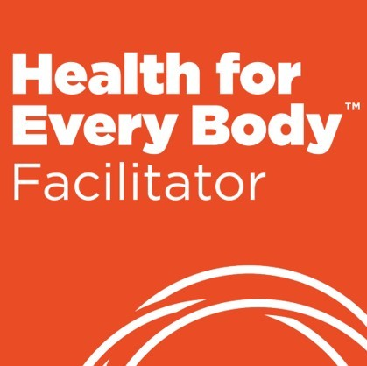
If these conclusions fit with your experience and you are looking for an evidence-based, effective way to help people make peace with their bodies and their food – consider our live, online Health for Every Body Facilitator Training and help us bring the realities of weight and health into the 21st century! The next training begins Tuesday January 8th, 2019 and more information is available now at: - https://salveopartners.com/products-services/health-for-every-body/.
Please feel free to contact me at jon@salveopartners.com if you want more information. Take care - Dr. Jon

